Vorlage 3 – Learning Apps-Links
https://learningapps.org/1661968
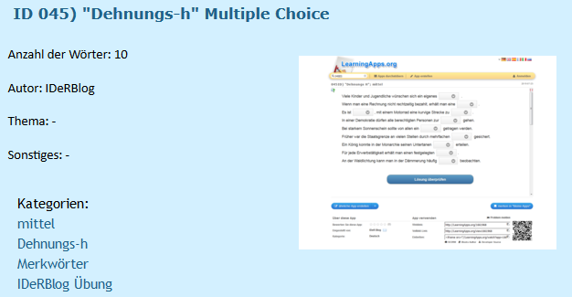

https://learningapps.org/1665047
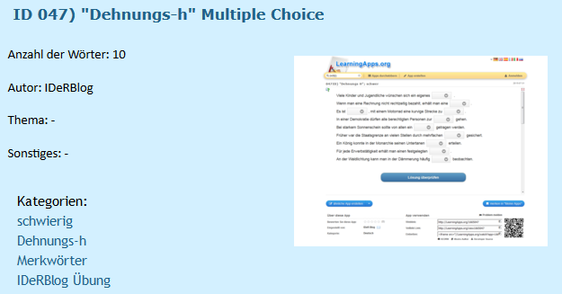

https://learningapps.org/1661983
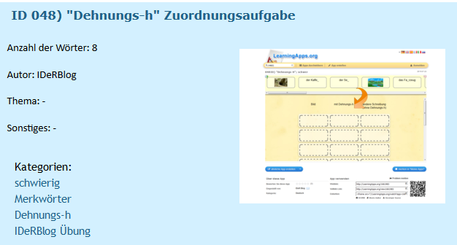

https://learningapps.org/1957861
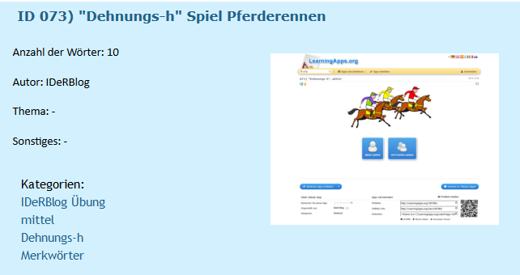

https://learningapps.org/1957812
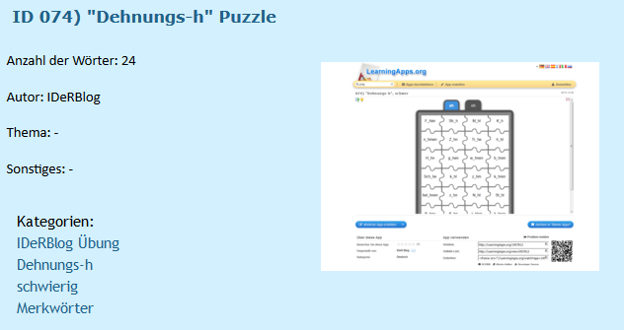

https://learningapps.org/1957796
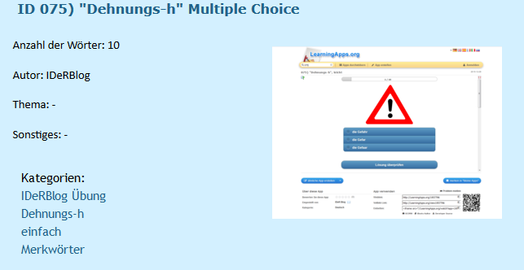

https://learningapps.org/1957774
